Scenario AI
Sadab Saman (2521387043)
Introduction: Scenario is an AI-powered creative platform used to generate, edit, and train custom images, game assets, characters, and visual designs. It is useful for designers, students, content creators, marketers, and game developers because it can create professional-quality visuals in minutes instead of hours. You can use it for making anime scenes, cinematic posters, AI classroom images, product concepts, YouTube thumbnails, and social media content. In daily life, it helps save time and money since you do not always need advanced drawing skills, expensive software, or a professional designer. For someone learning technology and engineering, Scenario can help turn ideas into visual prototypes, presentations, project concepts, and creative AI experiments quickly.
Prompt: Naruto Uzumaki is standing in a crowded, everyday street in Dhaka, Bangladesh, wearing his classic orange and black outfit. He is in a battle stance, holding a glowing Rasengan in his hand, blue chakra energy swirling intensely around him. The environment shows a typical urban Dhaka street with cycle rickshaws, small roadside shops, hanging electrical wires, street vendors, and weathered concrete buildings with colorful signboards.
The street is chaotic—people running away in panic, overturning rickshaws, scattered debris, and dust in the air. Late afternoon lighting with a warm golden glow, mixed with dramatic shadows. Cinematic composition, dynamic angle, motion blur, high detail, anime-realistic fusion style, intense energy effects, ultra-detailed textures, 4K resolution, volumetric lighting.
Output:
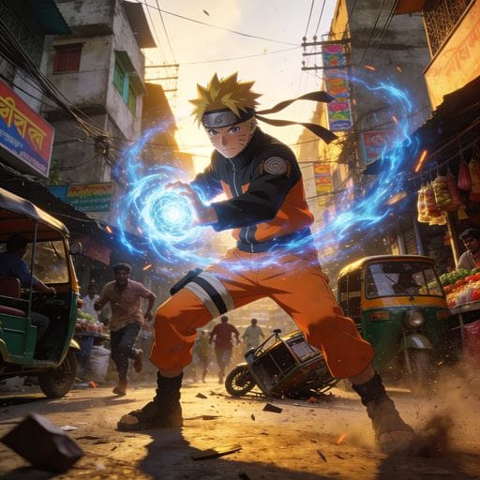

The output image shows a realistic anime-style action scene with strong energy effects and cinematic lighting. The detailed street environment and motion effects create a dynamic and chaotic atmosphere. Overall, the image successfully combines fantasy elements with a realistic urban setting.
Prompt engineering:
1. Be extremely specific about the scene or result
Instead of writing “make an AI classroom,” write:
“Modern university classroom, anime students sitting in rows, male teacher explaining artificial intelligence, holographic AI logo behind him, cinematic lighting, realistic shadows, ultra detailed.” The more precise your instructions are, the better the AI understands your vision.
2. Structure prompts in layers
A strong prompt usually follows this order:
Subject → Environment → Style → Lighting → Camera → Quality
Example: “Cyberpunk engineer working on circuits in a futuristic lab, rainy neon city outside window, anime cinematic style, blue-purple lighting, wide-angle shot, highly detailed, 4K.”
3. Use reference styles and artistic keywords
AI responds strongly to visual language like:
- Cinematic
- Photorealistic
- anime style
- volumetric lighting
- depth of field
- Unreal Engine style
- Studio Ghibli inspired
- ultra detailed
These keywords guide texture, mood, and rendering quality.
4. Add negative prompts to remove bad outputs.
Negative prompts tell the AI what to avoid.
Example: “Negative prompt: blurry face, extra fingers, distorted eyes, low quality, cropped body, bad anatomy.” This dramatically improves image cleanliness and realism.
5. Iterate like an engineer, not a gambler
Don’t completely rewrite the prompt every time. Change one variable at a time:
- lighting
- camera angle
- art style
- facial expression
- background
This helps you understand what actually changes the output and lets you systematically improve results.
Conclusion: Scenario is one of the strongest AI tools for generating game assets, cinematic scenes, anime-style art, and custom visual content. Compared to other AI image generators like Midjourney and Leonardo AI, Scenario AI is especially useful for creators who want consistent characters, branding, or game design workflows. Midjourney often produces more artistic and highly realistic images, while Leonardo AI is known for flexibility and beginner-friendly tools. However, Scenario AI stands out because it allows users to train custom AI models and maintain a consistent visual style across projects. For students, designers, and content creators, it is a powerful tool for quickly and efficiently turning creative ideas into professional visuals.

AI Assistance Used:
I used ChatGPT by OpenAI for assistance in refining and organizing the written descriptions of the prompt and output.

